Computer Networking Basics Activity

- IP Address:
Purpose: Shows the IP address and network configuration of your system.
Output: Shows Network interface, IP address, subnets masks.

- Ping:
Purpose: It tests the connectivity of your computer and another device.
Output: Displays the reply packets(both transmitted and received), response time and packet loss data.

- Traceroute:
Purpose: It shows the path taken by the data packets to reach the destination.
Output: List every router between your computer and the destination with the time taken.

- Nslookup:
Purpose: It resolves the domain name into the corresponding IP address.
Output: Displays the DNS server and IP Address of the requested domain.

- Netstat:
Purpose: Displays the list of active network and the listening ports.
Output: Shows the protocol(tcp/udp), local addresses, port numbers, and the status whether its listening or not.

- Network Diagram:
Web Server
Internet
Router
User

- How a request travels from your computer to a website?
- 1. Whenever a user enters a website address(e.g. google.com) in a browser, the browser first sends a request to a DNS server to fetch the website’s IP address.
2. Request is then forwarded from user’s computer to the router, which sends it over to the internet.
3. The request reaches the destination server, which processes it and sends the requested webpage back through the internet & router to the user’s computer and is displayed in browser.

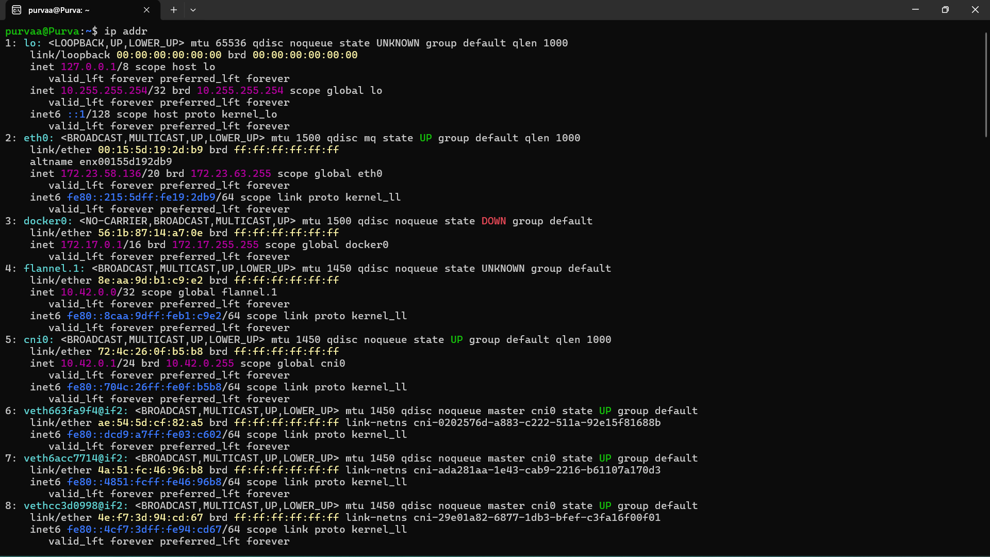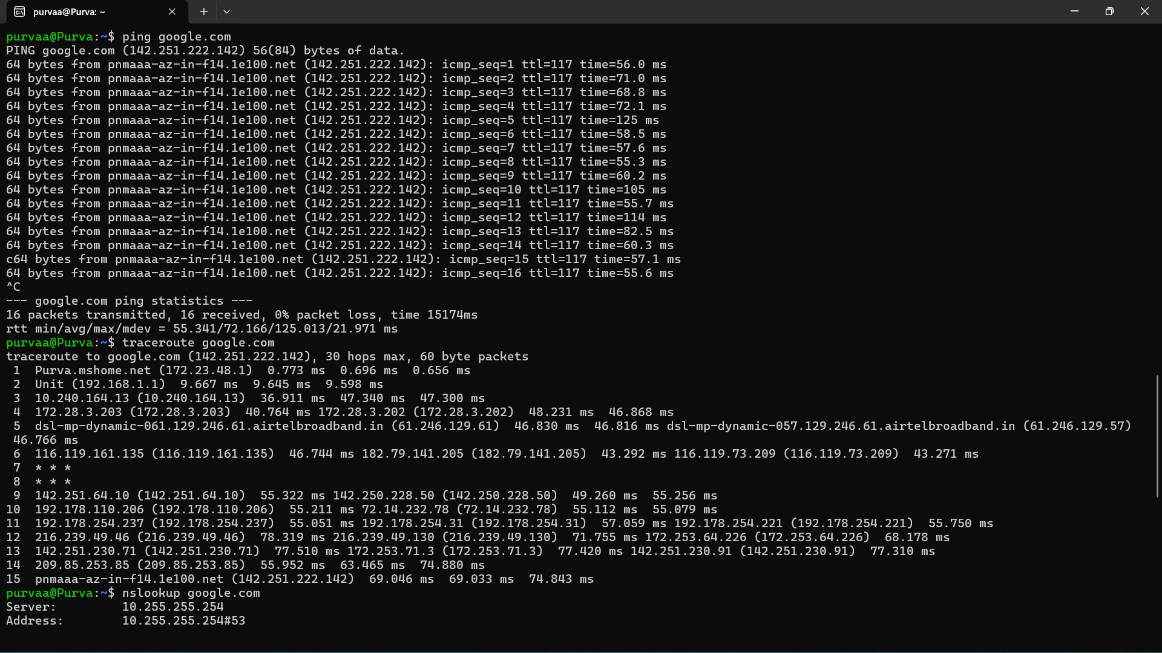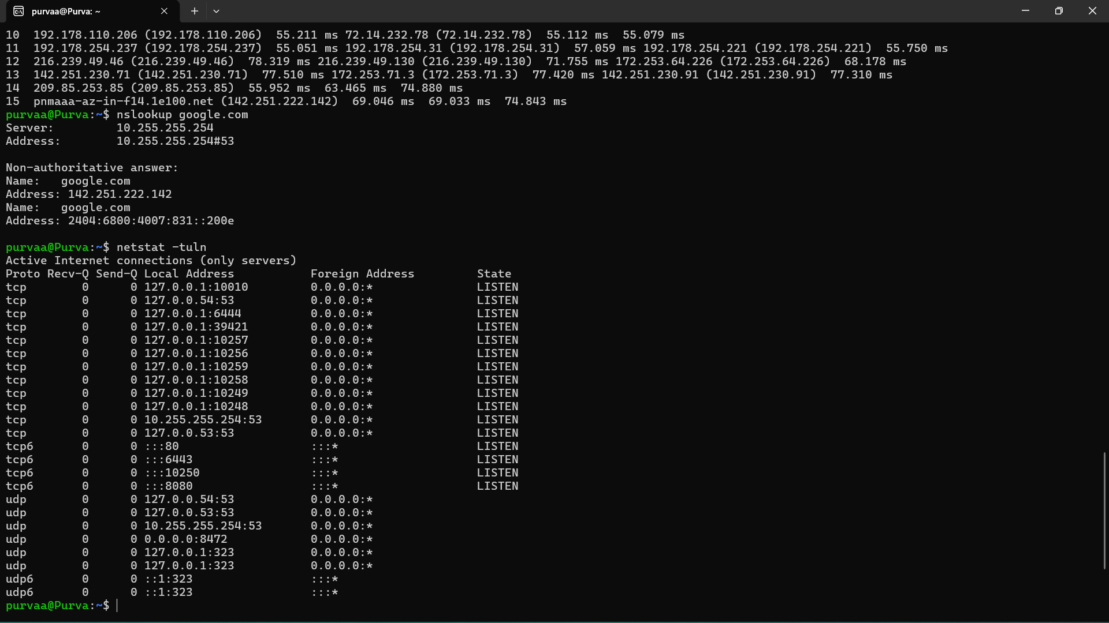

Name: Purva Wankhede
Date: 24 July 2026
Batch: B1

